English Activities
8° GRADE
Name _____________________________ date________________
- Read the text and answer the questions
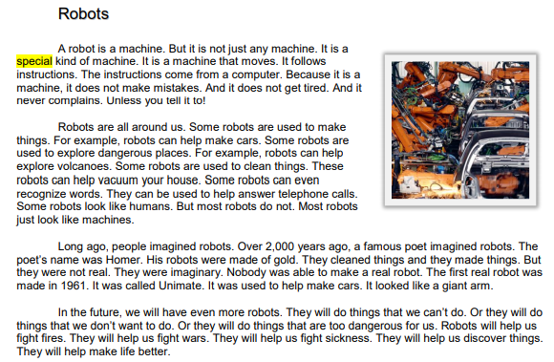
1) As used in paragraph 1, we can understand that something special is NOT  A. normal  B. expensive  C. perfect  D. tired | 2) According to the author, robots may be used to  I. make cars  II. explore volcanoes  III. answer telephone calls  A. I only B. I and II only  C. II and III only D. I, II, and III
3) What is the main purpose of paragraph 2? A. to show how easy it is to make a robot  B. to tell what a robot is  C. to describe the things a robot can do  D. to explain the difference between a robot and a machine | 4) According to the passage, when was the first real robot made?  A. 1961  B. 1900  C. 2003  D. 2000 years ago
5) Using the information in the passage as a guide, which of these gives the best use of a robot?  A. to help make a sandwich  B. to help tie shoes  C. to help read a book  D. to help explore Mars | 6) Which of these statements correctly summarizes how the author of this passage feels about robots?  A. Robots are old.  B. Robots are confusing.  C. Robots are helpful.  D. Robots are dangerous.

- Translate the text ROBOTS . If necessary use another sheet of paper.
______________________________________________________________________________________________________________________________________________________________________________________________________________________________________________________________________________________________________________________________________________________________________________________________________________________________________________________________________________________________________________________________________________________________________________________________________________________________________________________

- Learn the POSSESSIVE PRONOUNS
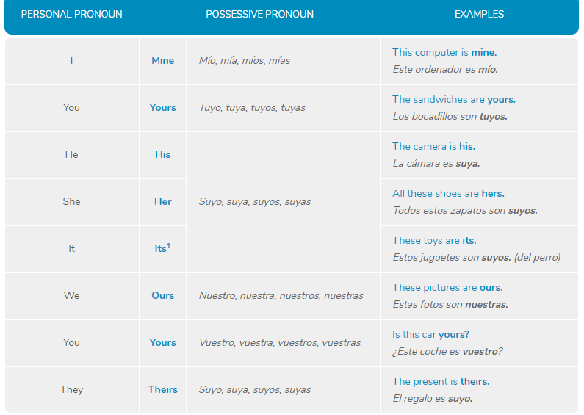
- Fill out the correct possessive pronoun!
1. I have a bike. It's ________ bike.
2. Mum and I have a boat. It's _________ boat.
3. The horse has an apple. It's ___________ apple.
4. John and Max have a skateboard. It's ____________ skateboard.
6. You have a dog. It's __________ dog.
7. Max and you have a dad. It's _____________ dad.

- Complete using the words from the box

