English Activities
7° GRADE
Name _____________________________ date________________
- At home, remember vocabulary about :
NUMBERS 1- 1000 – SCHOOL ELEMENTS – PLACES IN THE CITY

- Read the text and answer the questions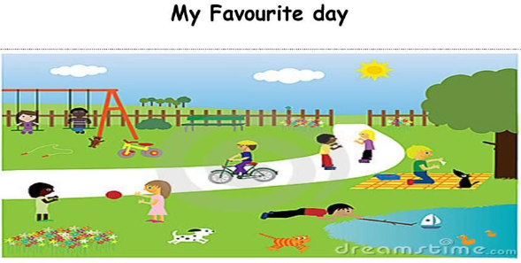
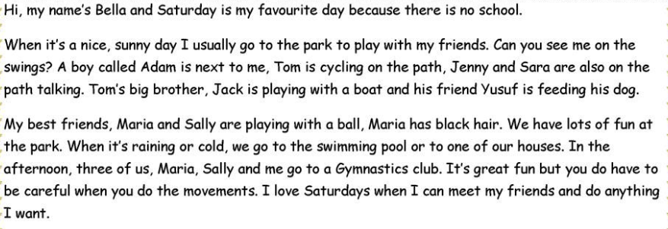
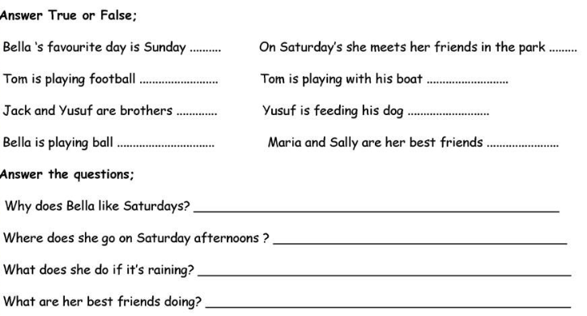
- Translate the text my favorite day into Spanish.

____________________________________________________________________________________________________________________________________________________________________________________________________________________________________________________________________________________________________________________________________________________________________________________________________________________________________

- Look at the explanation of the use of THERE IS and THERE ARE
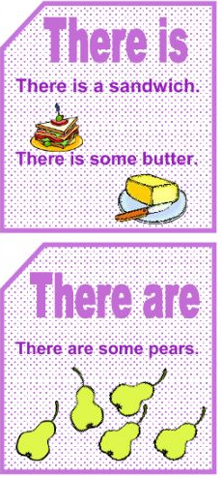
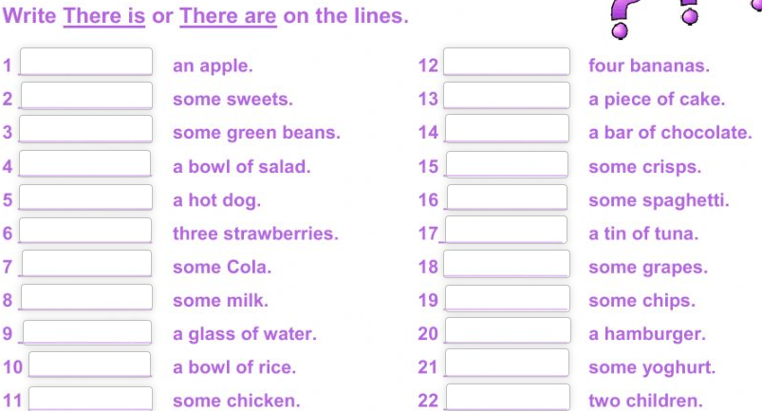
- Learn the quantifiers.
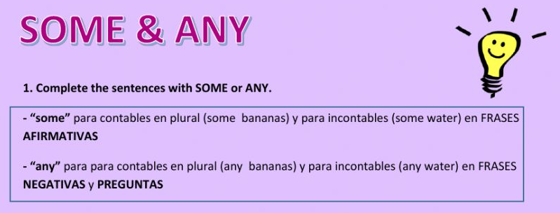

Now do some excercises…. Ty
