English Homework 3
8° GRADE
Name _____________________________ date________________
- Read text on page 11 from your book

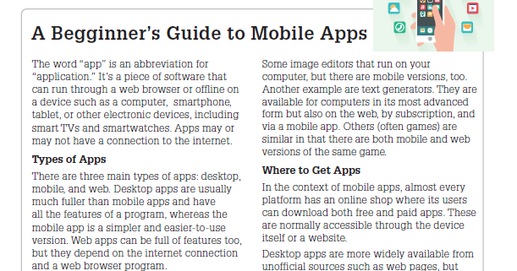
Write a vocabulary of 30 words from the text
- Do exercise 1 - 2 on page 11

- Choose 15 words from the vocabulary and write a sentence in English.

