English Homework 4
7° GRADE
Name _____________________________ date________________
Present Continuous

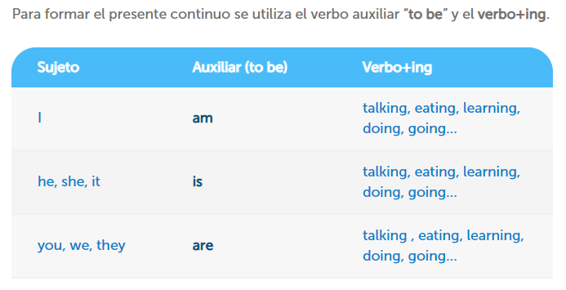
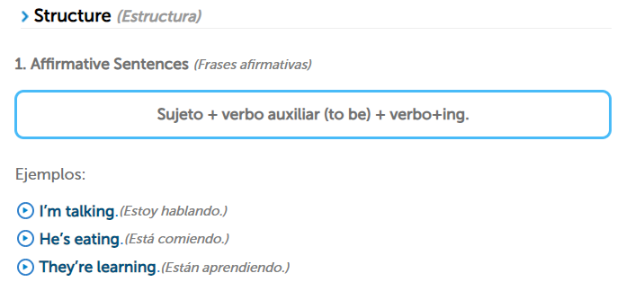
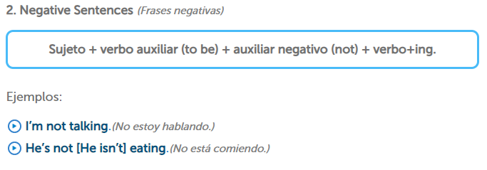
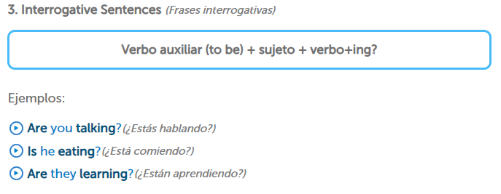
ARE
AM
IS
REMEMBER
The verb To Be in present functions like this: I HE, SHE, IT WE, YOU, THEY

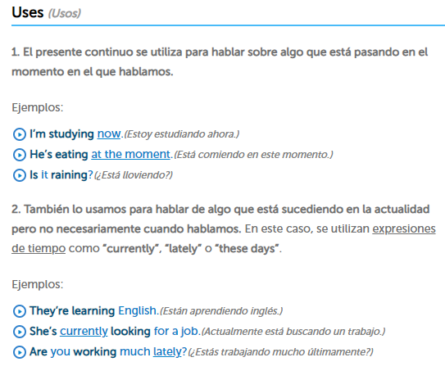
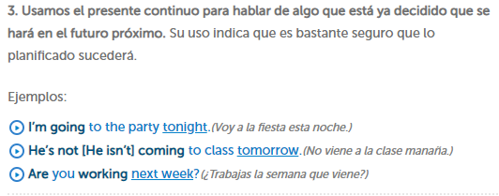

Now practice
Form sentences in the present continuous tense.
Example: I / watch / TV I am watching TV

- I / sit / on a chair _____________________________________________________
- He / smoke / a cigar ____________________________________________________
- They / play / football _____________________________________________________
- It / rain ______________________________________________________
- Anne / write / a letter _____________________________________________________
- Bob / read / a book _____________________________________________________
- We / walk / to work _____________________________________________________
- You / eat / an apple _____________________________________________________
- They / run / around the park _______________________________________________
- I / wait / for the bus _____________________________________________________

