Name ____________________________ _ Date________________
- Read the text and answer the questions
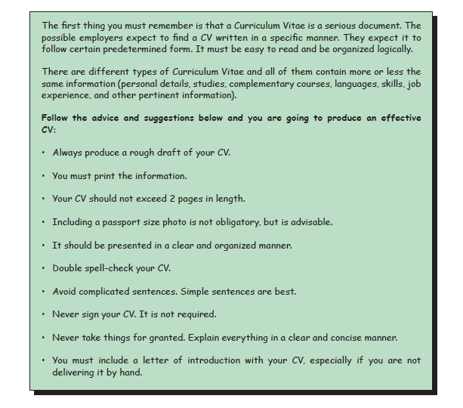
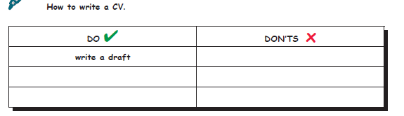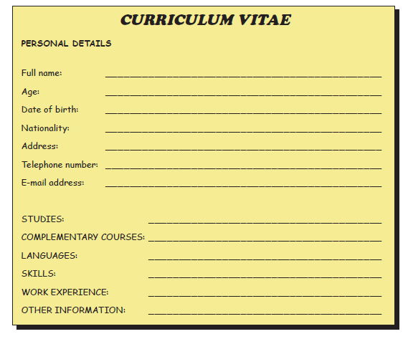
Complete your own CV

- Translate the text in your copybook

- Dialogue.

Study the dialogue at home and practice it
Mr Bean:- Hello Mr Jones, what do you do for a living?
Mr Jones:- I am a teacher in a high school.
Mr Bean:- A teacher? that sounds like a lot of hard work.
Mr Jones:- Sometimes. I teach high school children.
Mr Bean:- Is there a lot if of students in your class?
Mr Jones:- Most classes have about fifty students on average.
Mr Bean:- Do like your job?
Mr Jones:- yes, It is so rewarding. Teaching at high school is easier then primary.
The students are less naughty.

- From your activity book do the following activities

Activities 1 -2 | Page 6 | Activity book
Vocabulary of 20 words | Page 7 | Activity book
Activity 5 | Page 9 | Activity book
Activities 6 -7 | Page 10 | Activity book

