English Activities
6° GRADE
Name _____________________________ date________________
- At home, remember vocabulary about :
FAMILY – COLORS – NUMBERS 1- 10 – SCHOOL ELEMENTS

- Read the text.
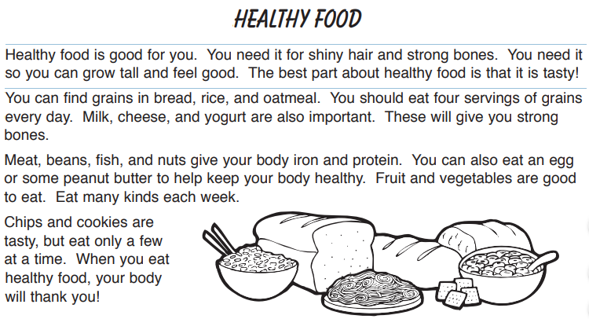
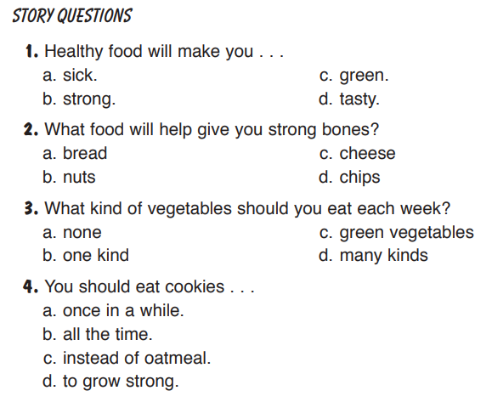
- Write a vocabulary of 20 new words from the text in Spanish.

ENGLISH | SPANISH | ENGLISH | SPANISH

- Find food names in the following crossword
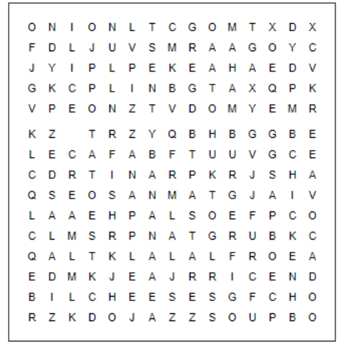
- Label the pictures about health problems.

