Name ____________________________ _ Date________________
- Imagine you are applying for a job. Look and complete the Application form on page 20 from your book

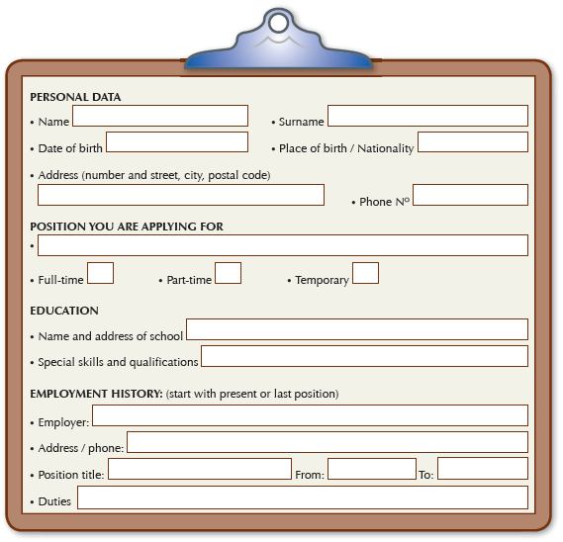
Try to answer according your personal interests in future jobs

