Name ____________________________ _ Date________________

- Read the text on pages 34, 35
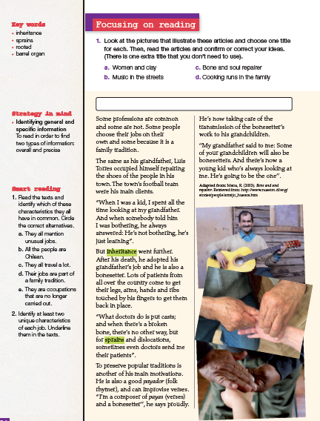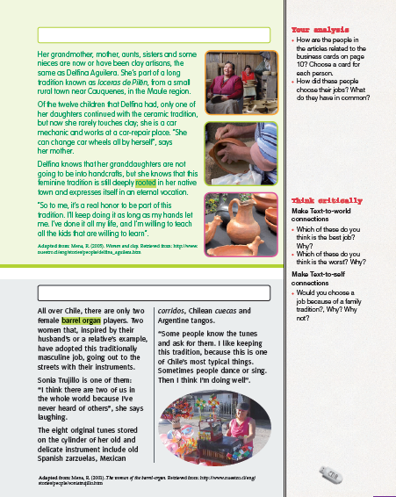
Do activities Smart Reading (1, 2)
- Write a vocabulary of 30 words you don’t know from the text.
- Choose 15 words from the vocabulary and write a sentence for each one

