Name ____________________________ _ Date________________
- Remember FIRST CONDITIONAL
In Spanish https://www.lewolang.com/gramatica-inglesa/23/first-conditional
In English https://www.youtube.com/watch?v=P9WhRO8WT0E

The First Conditional
The first conditional has the present simple after 'if', then the future simple in the other clause:
- if + present simple, ... will + infinitive
It's used to talk about things which might happen in the future. Of course, we can't know what will happen in the future, but this describes possible things, which could easily come true.
Exercises
Put the verb into the correct first conditional form:
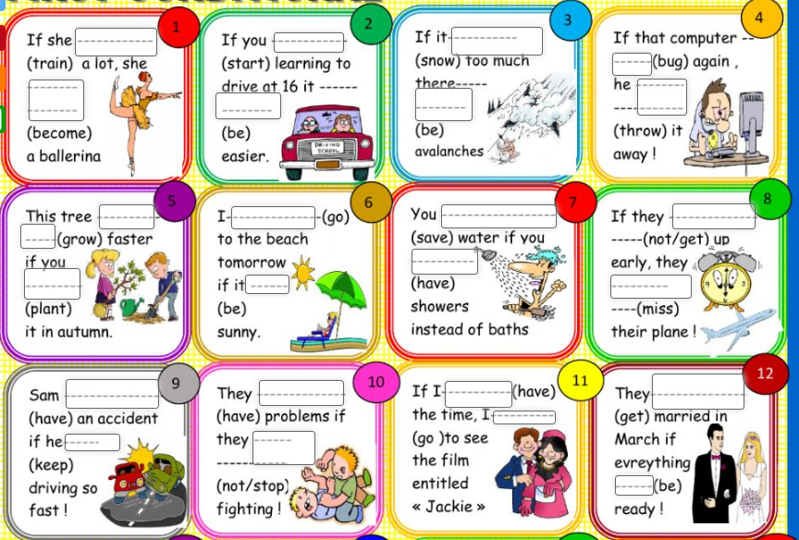

- Learn the use of Connectors for questions

Now do some exercises.
Complete the questions according to the answers using the words in bold
